HW#1 Solution

3.1.2(a&b)

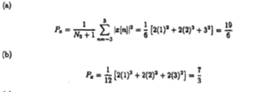

3.2.7(d,e,f)

|  |  |
| --- | --- |
|  |  |
| d | e |
|  |  |
| f |  |

3.3.2



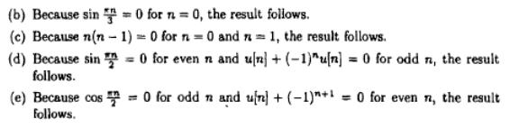

3.3.3

|  |  |
| --- | --- |
| a. | b. |
| c. | d. |
| e. |  |

3.4.11

